#include <iostream>
#include <array>
#include <string>
#include <stack>
#include <queue>
#include <algorithm>

//item struct
struct item {
int id;
int weight;
int profit;
};

struct Node{
int index;
int weight;
int profit;
float bound;

};

struct Compare {
bool operator()(Node const& a, Node const& b) {
return a.bound < b.bound; // higher bound = higher priority
}
};

float bound(Node u, int n, int W, int weight[], int profit[]){
if(u.weight >= W){
return 0;
}

float result = u.profit;
int j = u.index + 1;
int totweight = u.weight;

while(j < n && totweight + weight[j] <= W){
totweight += weight[j];
result += profit[j];
j++;
}

if(j < n){
result += (W - totweight) * ((float)profit[j] / weight[j]);
}

return result;
}

int backtracking(int W, int n, int weight[], int profit[] )
{
std::stack<Node> st;

Node u, v;
int maxprofit = 0;

//root node
v.index = -1;
v.profit = 0;
v.weight = 0;
v.bound = bound(v, n, W, weight, profit);

st.push(v);

while(!st.empty()){
v = st.top();
st.pop();

if(v.bound > maxprofit){
u.index = v.index + 1;

if(u.index >= n) continue;

//include
u.weight = v.weight + weight[u.index];
u.profit = v.profit + profit[u.index];

if(u.weight <= W && u.profit > maxprofit){
maxprofit = u.profit;
}

u.bound = bound(u, n, W, weight, profit);

if(u.bound > maxprofit){
st.push(u);
}

//exclude
u.weight = v.weight;
u.profit = v.profit;
u.index = v.index + 1;
u.bound = bound(u, n, W, weight, profit);

if(u.bound > maxprofit){
st.push(u);
}
}
}

return maxprofit;

}

int breathFirstSearch(int W, int n, int weight[], int profit[]){
int maxProfit = 0;
std::queue<Node> q;

Node u, v;
v.index = -1;
v.profit = 0;
v.weight = 0;
v.bound = bound(v, n, W, weight, profit);

q.push(v);

while(!q.empty()){
v = q.front();
q.pop();

//only continue if promising
if(v.bound > maxProfit){
u.index = v.index + 1;

if(u.index >= n){
continue;
}

//include
u.weight = v.weight + weight[u.index];
u.profit = v.profit + profit[u.index];

if(u.weight <= W && u.profit > maxProfit){
maxProfit = u.profit;
}

u.bound = bound(u, n, W, weight, profit);

if(u.bound > maxProfit){
q.push(u);
}

//exclude
u.weight = v.weight;
u.profit = v.profit;

u.bound = bound(u, n, W, weight, profit);
if(u.bound > maxProfit){
q.push(u);
}
}
}

return maxProfit;

}

int bestFirstSearch(int W, int n, int weight[], int profit[]){
int maxProfit = 0;
std::priority_queue<Node, std::vector<Node>, Compare> pq;

Node u, v;
v.index = -1;
v.profit = 0;
v.weight = 0;
v.bound = bound(v, n, W, weight, profit);

pq.push(v);

while(!pq.empty()){
v = pq.top();
pq.pop();

//only continue if promising
if(v.bound > maxProfit){
u.index = v.index + 1;

if(u.index >= n){
continue;
}

//include
u.weight = v.weight + weight[u.index];
u.profit = v.profit + profit[u.index];

if(u.weight <= W && u.profit > maxProfit){
maxProfit = u.profit;
}

u.bound = bound(u, n, W, weight, profit);

if(u.bound > maxProfit){
pq.push(u);
}

//exclude
u.weight = v.weight;
u.profit = v.profit;

u.bound = bound(u, n, W, weight, profit);
if(u.bound > maxProfit){
pq.push(u);
}
}
}

return maxProfit;

}

int main([[maybe_unused]] int argc, [[maybe_unused]] char* argv[])
{
int weight[] = {2, 5, 7, 3, 1};
int profit[] = {20, 30, 35, 12, 3};
int W = 9;
int n = 5;

std::vector<item> items;

for (int i = 0; i < n; i++) {
items.push_back({i, weight[i], profit[i]});
}

std::sort(items.begin(), items.end(), [](item a, item b){
return (double)a.profit/a.weight > (double)b.profit/b.weight;
});

for(int i = 0; i < n; i++){
weight[i] = items[i].weight;
profit[i] = items[i].profit;
}

int backtrack = backtracking(W, n, weight, profit);
int bfs = breathFirstSearch(W, n, weight, profit);
int bestfirst = bestFirstSearch(W, n, weight, profit);

std::cout << "MAX PROFIT (Backtracking): " << backtrack << std::endl;
std::cout << "MAX PROFIT (BFS): " << bfs << std::endl;
std::cout << "MAX PROFIT (Best First): " << bestfirst << std::endl;

return EXIT_SUCCESS;
};

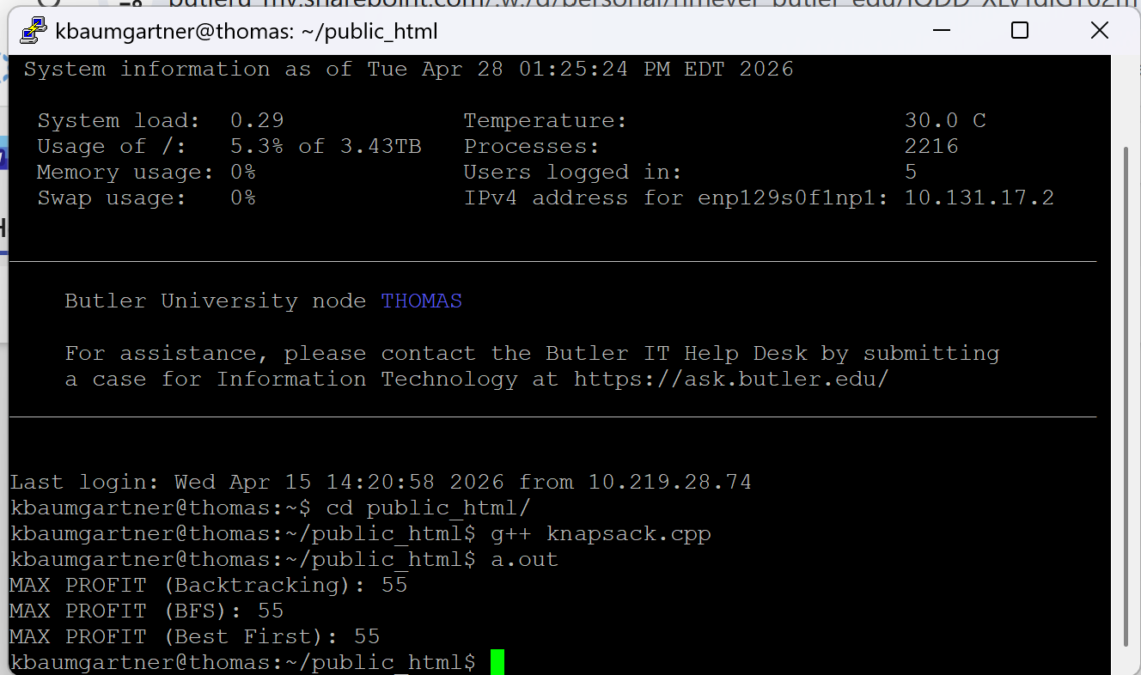

In the code, all of the knapsack algorithms have the same worst-case complexity. BFS uses levels, while best first uses the item with the most potential. While all three methods are exponential in worst case, the effectiveness of the bounding function and the node selection play a crucial role in reducing the number of nodes that are explored, allowing best-first search to generally offer the best practical performance.

